# **Phase 7 – Integration & External Access**

### **1. Introduction**

This phase integrates the Punjab Flood Relief CRM with external services and APIs. It enables real-time communication with outside systems such as maps or demo APIs, ensures volunteers and NGOs get accurate data, and allows external users (donors) to interact through portals.

### **2. Named Credential Setup**

**Purpose**: Provides a secure connection to an external API.

**Steps**:

* Navigate: **Setup → Quick Find → Named Credentials → New Named Credential**
* Fill details:
  + **Label**: DemoAPI
  + **Name**: DemoAPI
  + **URL**: <https://raw.githubusercontent.com/chinmay20cc/Disaster_Relief_CRM_Salesforce/main>
  + **Enabled for Callouts** ✅
  + **Authentication**: No Authentication (via External Credential if required).
* Save.

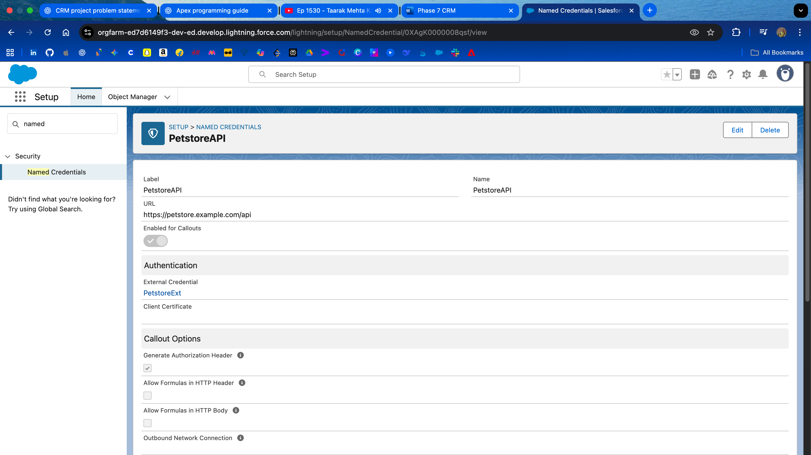

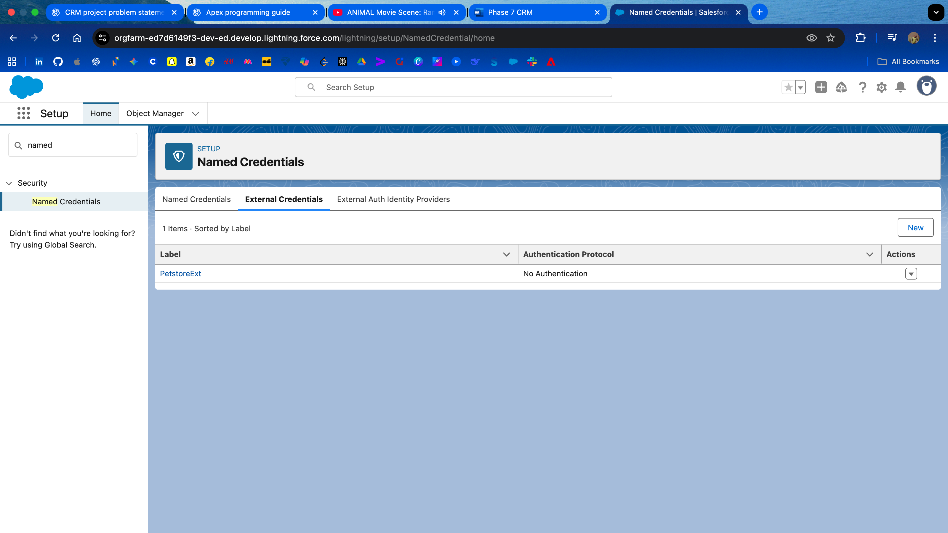

### **3. External Service Registration**

**Purpose**: Registers the schema (API contract) so Salesforce can use it in Flow without Apex.

**Steps**:

* Navigate: **Setup → External Services → New External Service**
* Fill details:
  + **External Service Name**: DemoService
  + **Description**: Demo API connected to Salesforce for Flood Relief CRM testing
  + **Named Credential**: Select **DemoAPI**
  + **Relative URL**: /demo-service.json
* Click **Save**.

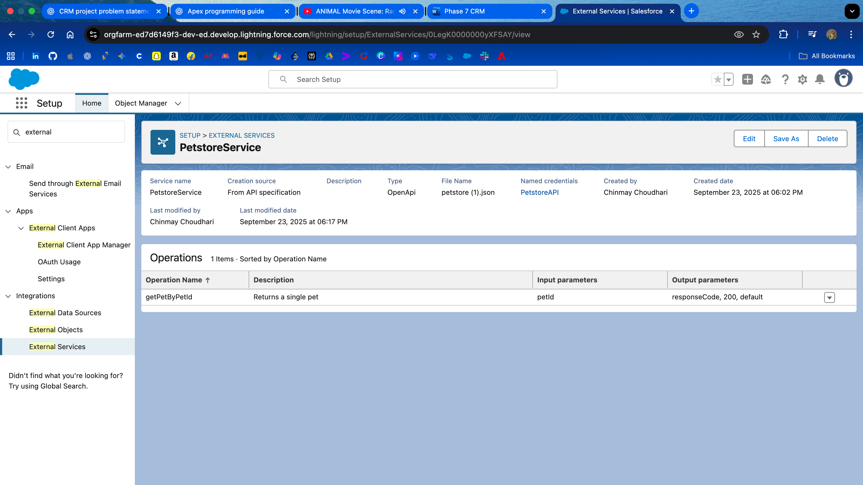

### **4. Flow Integration (Using External Service)**

**Purpose**: Demonstrates how external APIs can be called from Salesforce Flows.

**Steps**:

* Navigate: **Setup → Flows → New Flow**
* Select **Screen Flow → Create**
* Add a **Screen Element** → Text/Number input for “Enter ID”
* Add **Action** → Search for DemoService → Select operation (e.g., hello)
* Map input variable to operation parameter
* Add **Screen Element** → Display Text → Show API Response ({!hello.message})
* Save & Activate the Flow

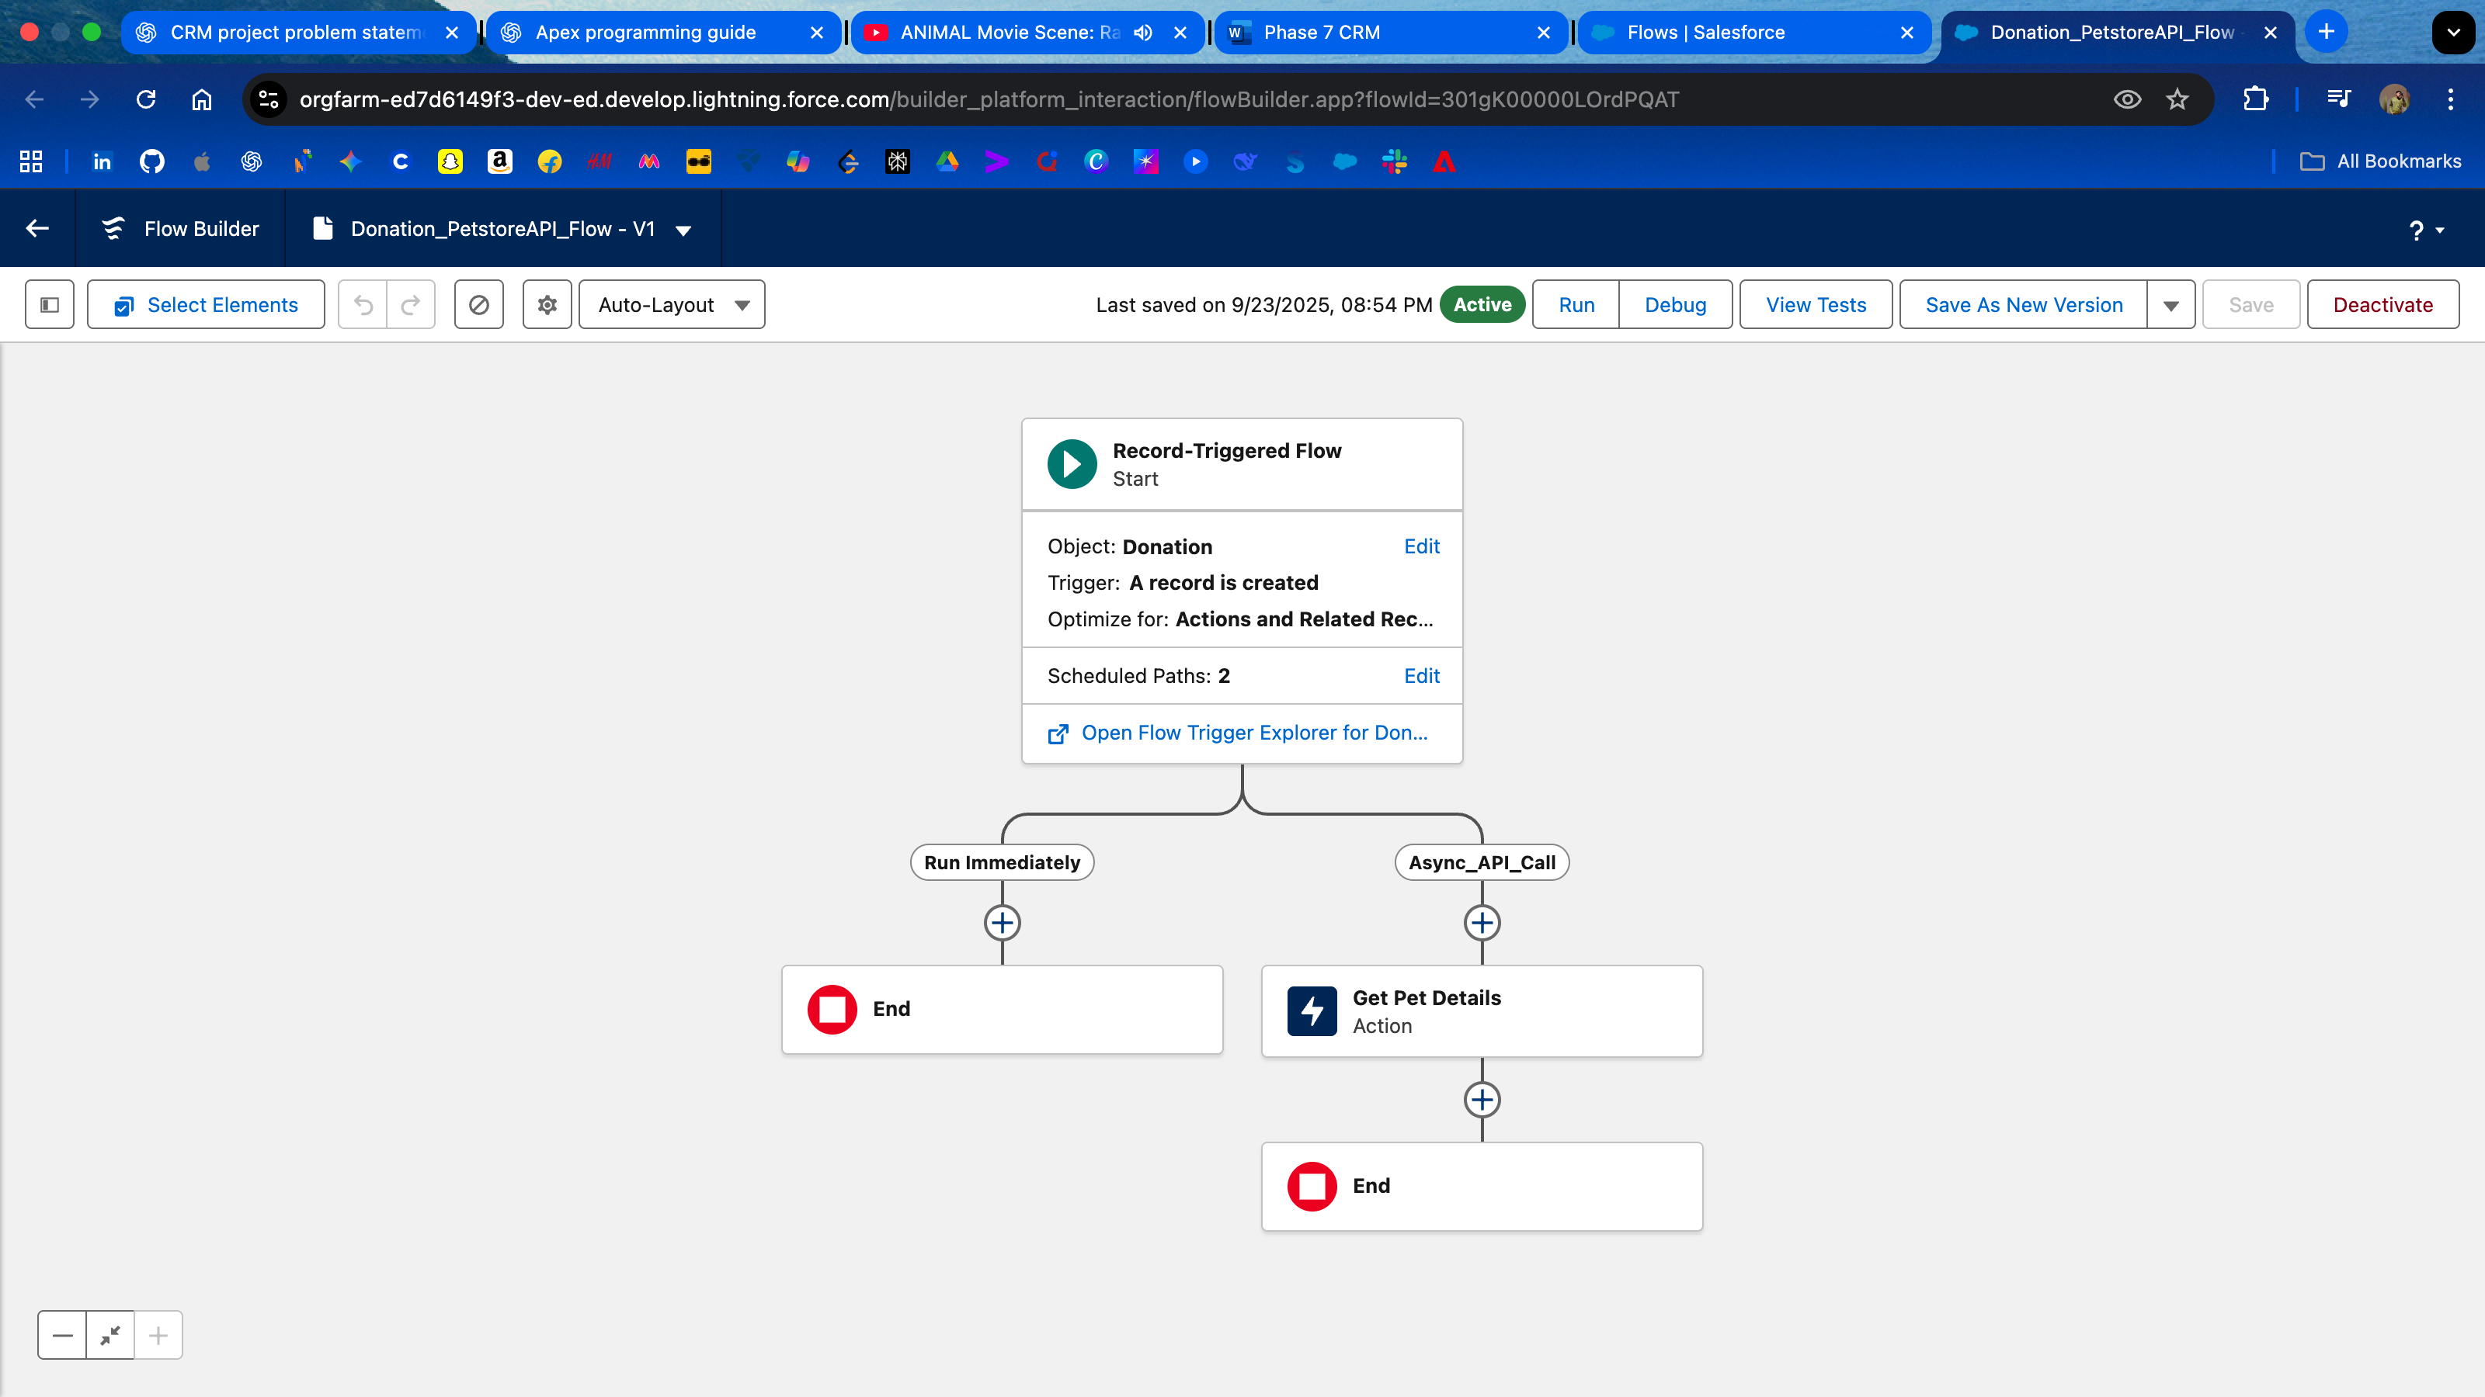

### **5. Conclusion**

This phase connected Salesforce CRM with external APIs using **Named Credentials** and **External Services**.  
 It showed how a simple demo service can be called in a Flow, and how donors/volunteers could also access information through an external portal.  
 These integrations lay the foundation for adding real APIs (e.g., Google Maps, Payment Gateways) in the future.